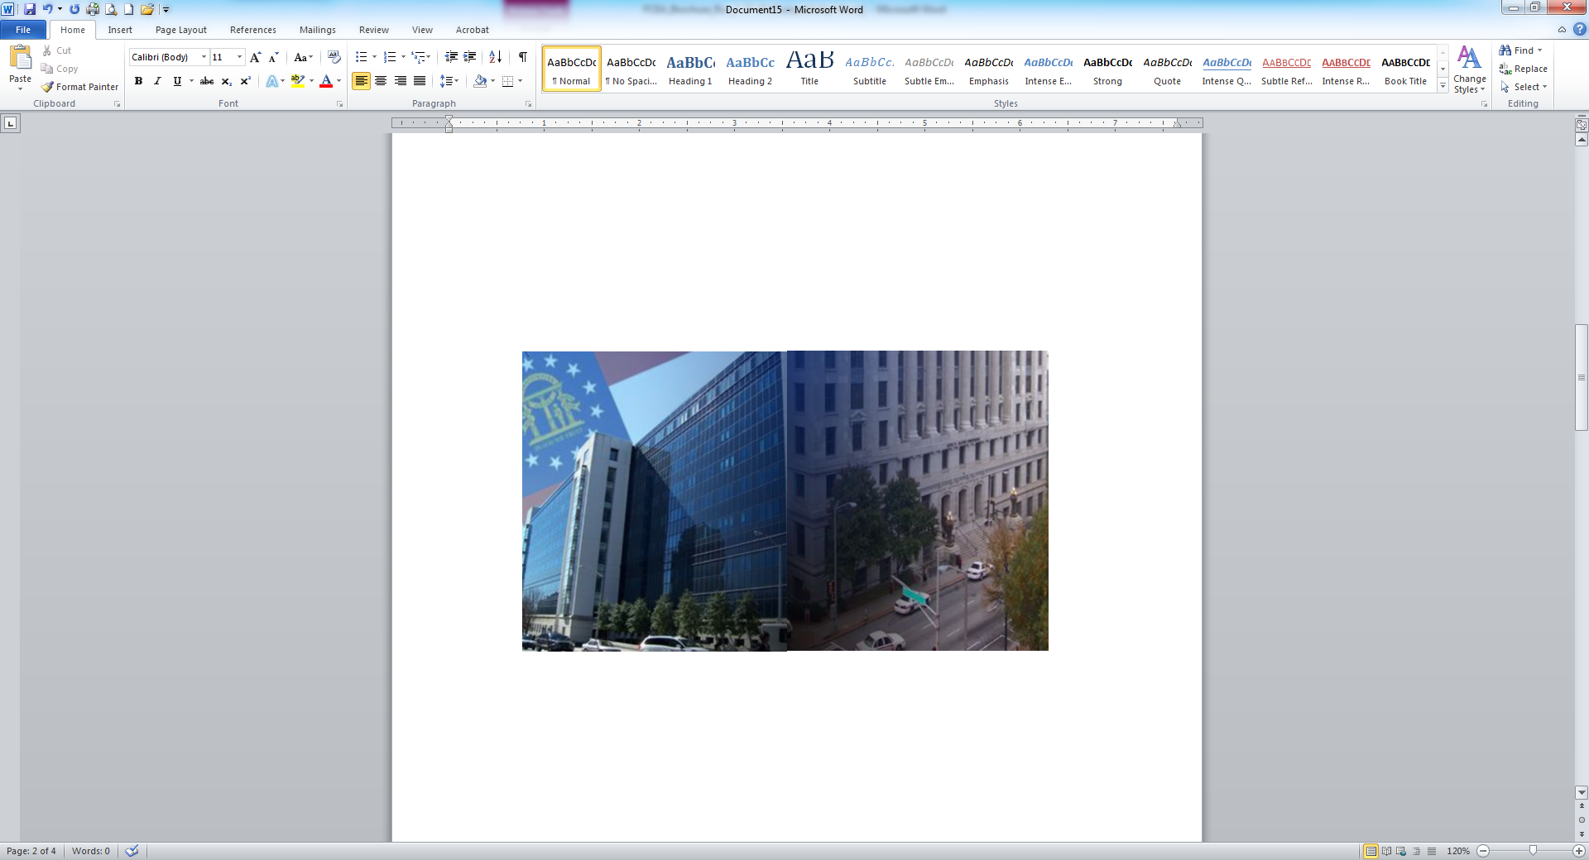
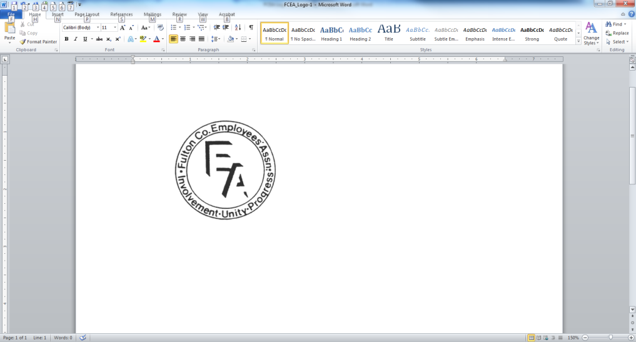
M

FCEA Executive Board
Jori Smith-Mann ~ President
Melba Blount ~ 1st Vice President
Jennifer Hill ~ 2nd Vice President
Alicia Gibbons ~ 3rd Vice President
Daphne Ballard ~ Secretary

Nadine Childs-James ~ Assistant Secretary
Consuello Peek-Dozier ~ Treasurer

Learyetta Hunter-Stills ~ Financial Secretary

Brenda Whitehead ~ Information Officer

Nakia Roberts ~ Events Coordinator

Pamela Coman ~ Parliamentarian

Shariff Jones ~ Website Editor

Morgan Diaz ~ Newsletter Editor

Tona’e Clements ~ Liaison
Valerie Tillman-Logan~ Sergeant At-Arms

Kendra Lattimore ~ Chaplain

0

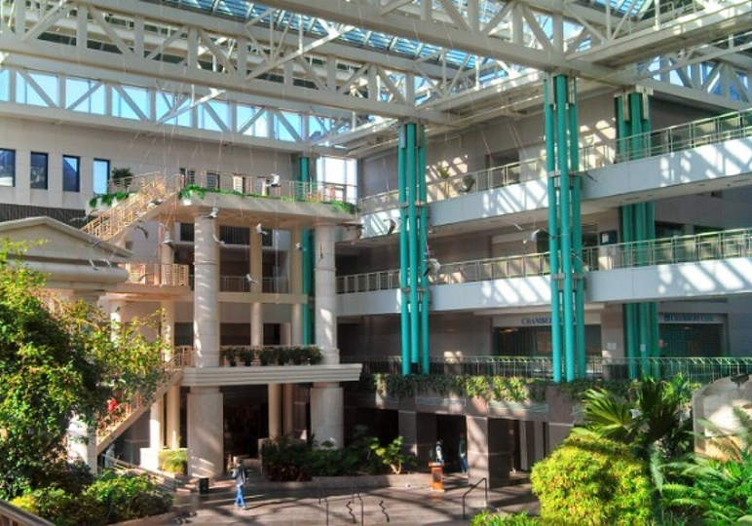
For more information:
Call
(404) 613-5752
Or write:
Fulton County Employees’ Association
Attn: Jori Smith-Mann
P.O. Box 4815
Atlanta, GA 30302
Email: fcea@fultoncountyga.gov

Visit our website at:
www.fcemployees.org

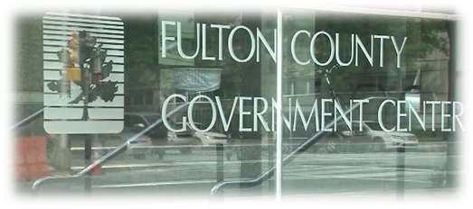

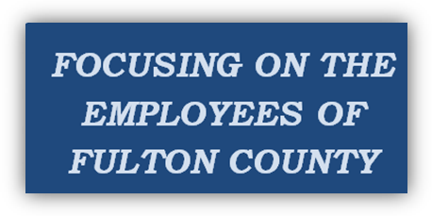

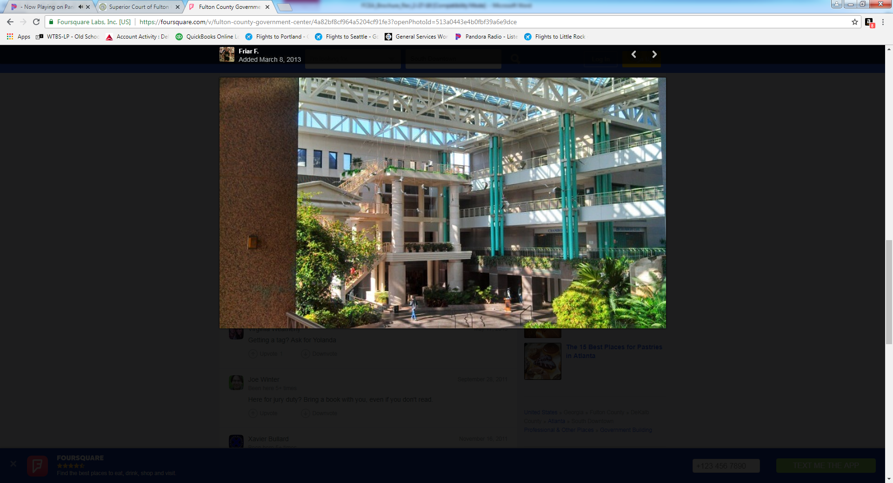

FULTON COUNTY EMPLOYEES’ ASSOCIATION
What is the Fulton County Employees’ Association?
The Fulton County Employees’ Association (FCEA) is a State chartered non-profit organization formed in 1969. The purpose of FCEA is to engage in various activities that will benefit and uplift the morale of the employees of Fulton County and for any other lawful purpose not specifically prohibited to non-profit organizations under the applicable laws of the State of Georgia and/or the Constitution of the United States. FCEA represents all Fulton County employees.
FCEA communicates with elected and appointed officials of Fulton County and its sub-agent and/or agencies to discuss members’ concerns. The nature of dialogue ranges from safety conditions and benefits relative to the workplace. In Essence, we are here for YOU. There is strength in numbers. Join and be heard.

Benefits for Members
County-Wide Networking
Quarterly Newsletter
Assistance with Employee Issues
Scholarship Fund Awards
Participation with Events & Projects
Service to Others
Lunch Meetings
FCEA T-Shirt
Monthly Door Prize Drawing

Membership Dues
$5.00 per pay period ($10.00 per month)


FCEA Events & Fairs
Pop Up Shops
Summer Camp Fair
Shoebox Project
Member and Business Spotlight
Monthly Meetings
Once a quarter monthly luncheon
Book/Author Fair
Officers Swearing in Ceremony
Partnership with HR and Employees Appreciation
Adult & High School College Fair
Scholarship Awards
Annual Holiday Celebration
Community Service

Your Membership Is Important
Meetings are held every 4th Tuesday of each month
12:00 pm – 1:00 pm
With a luncheon once a quarter.
All employees are invited.
Door Prize Drawing Each Month
JOIN & BE EMPOWERED!


