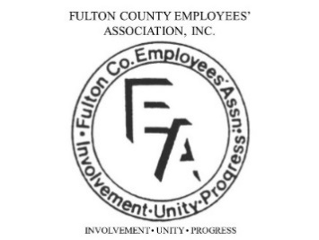

FULTON COUNTY EMPLOYEE’S ASSOCIATION VOLUNTEER LOG

Beginning 2022 the Fulton County Employee’s Association (FCEA) Scholarship Committee implemented the requirement that members of the Association are required to complete a total of 10 volunteer hours per year.

**Eligibility requirements include:**

* Five (5) hours of attendance at FCEA monthly meetings or committee meetings.
* Five (5) hours of volunteer service for FCEA committee related activities.

The purpose of the log is to track volunteer hours per month. Please complete your hours and send to your committee chair to verify your hours. The committee chair will submit your hours to the 2nd Vice President, Scholarship Chairperson for additional verification.

FCEA Committees:

* Membership Jennifer Hill
* Scholarship Melba Blount
* By-Laws Micah Womack
* Events Nakia Roberts
* Fundraiser Alicia Gibbons
* Community Service Alicia Gibbons
* Other Jori Mann

|  |
| --- |
| Month and Year Submitted: |

|  |  |  |  |  |
| --- | --- | --- | --- | --- |
| NAME | DATE | Hours Completed | EVENT | COMMITTEE CHAIR APPROVAL |
|  |  |  |  |  |
|  |  |  |  |  |
|  |  |  |  |  |
|  |  |  |  |  |

Total Hours Completed

Approved By Scholarship Chairperson: